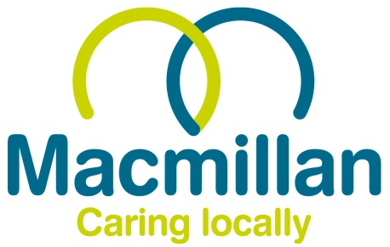
SARAH GREEN GOLF TOURNAMENT
2025 – Prize Winning Results:

- Individual Stapleford
  - 1st – Leigh Westfield (37 pts)
  - 2nd – Andrew Singleton (36 pts) – on countback
  - 3rd – Ben Richards (36 pts)
- Team Stapleford
  - 1st – Haighy’s Hackers (110 pts)
  - 2nd – Fretton’s Solicitors (107 pts)
  - 3rd – Here Fore Beer (105 pts)
- Pink Ball Competition (Team)
  - Sir Shankalot
- Nearest the Pin (5)
  - Ian Sargeant
- Longest Drive (Hole 15)
  - Tony Gardner
- Putting Competition
  - Ben Richards
- 2’s Competition
  - Dan Mersh
  - Ian Sergeant (X2)
- Best Team Outfit/Hats
  - Fred’s Four Ball
- Fairway Super Heavyweights (Team)
  - 18 Holes, 0 Morals (445 Gross)
- Chump of the Day
  - Andy Thompson

